Hey uh thanks for checking this!

There are currently 200+ (i'm too lazy to count rn) meshes that you can use as of 3/13/2025

If you are the owner of one of these messages I would like to put you in the credits so you can get the proper credits.

Thank you for reading

P.S. The only reason why there's "A or ! " at the start of some meshes is to make this appear up top, sorry about that.

3/13/25 uhm, i forgot I made this project i’m back now (yay..) new things include more .mesh files and just basically more things thanks for actually checking this out its dope to see that

Hold on..

*refreshes*

25 thousand people viewed this.

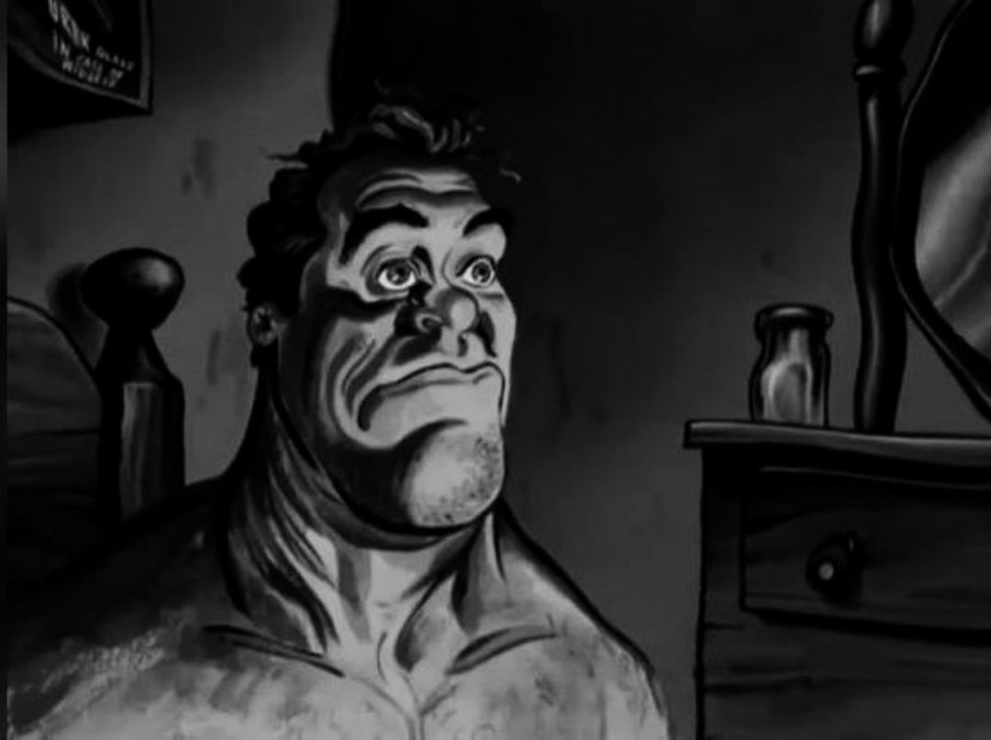

In all seriousness thanks for uhm actually viewing this I don’t know why this blew up unless some person shouted this out..?

P.S Realized that the folders weren't there so I fixed that so everything should be there now!

Empty page ignore ig

⠀⠀⠀⠀⠀⠀⠀⠀⠀⢠⡶⠶⠶⢦⣄⡀⠀⠀⠀⠀⠀⠀⣀⠀⠀⠀⠀⠀⠀⠀⠀⠀⢀⣀⣀⣤⡀⠀⠀⠀⠀⠀⠀⠀⠀⠀⠀⠀⠀⠀⠀
⠀⠀⠀⠀⠀⠀⠀⠀⣰⠋⠀⠀⠀⠀⠈⠙⢷⣄⣀⣀⣤⣤⣽⣿⠲⣤⣀⣠⣤⣶⠛⠋⠉⠀⠀⠈⢿⡀⠀⠀⠀⠀⠀⠀⠀⠀⠀⠀⠀⠀⠀
⠀⠀⠀⠀⠀⠀⠀⢿⡟⠒⠶⠲⠲⠖⠒⠒⠚⠛⠉⠀⠀⠀⠀⠈⢳⣄⣻⠟⠁⣿⠀⠀⠀⢀⣤⠀⠈⣷⠀⠀⠀⠀⠀⠀⠀⠀⠀⠀⠀⠀⠀
⠀⠀⠀⠀⠀⠀⠀⣾⠀⠀⠀⠀⠀⠀⠀⠀⠀⠀⠀⠀⠀⠀⠀⠀⠀⠀⠈⠀⠲⠏⠀⣠⠾⠋⢹⠀⠀⣿⠀⠀⠀⠀⠀⠀⠀⠀⠀⠀⠀⠀⠀
⠀⠀⠀⠀⠀⠀⣰⢿⠀⠀⠀⠀⠀⠀⠀⠀⠀⠀⠀⠀⠀⠀⠀⠀⠀⠀⠀⠀⠀⣠⠞⠉⠀⠀⢸⠀⠀⣿⠀⠀⠀⠀⠀⠀⠀⠀⠀⠀⠀⠀⠀
⠀⠀⠀⠀⠀⡀⣿⣸⣇⠀⠀⠀⢀⣤⠶⣤⡀⠀⢠⡞⠛⠳⣤⡀⠀⠀⠀⠀⠀⠸⡆⠀⠀⠀⣾⠀⠀⣿⠀⠀⠀⠀⠀⠀⠀⠀⠀⠀⠀⠀⠀
⠀⠀⠀⠈⢿⡋⠉⠉⠁⠀⠀⠀⢸⡃⠀⠀⢻⠀⢺⡄⠀⠀⠈⣿⠀⠀⠀⠀⠀⠀⢷⠀⠀⢠⡏⠀⠀⡿⠀⠀⠀⠀⠀⠀⠀⠀⠀⠀⠀⠀⠀
⠀⠀⠀⠀⠈⣷⠀⠀⠀⠀⠀⡀⣸⣷⣄⣠⡾⠃⠈⠻⣦⣄⣴⠟⠀⠀⠀⠀⠀⠀⢸⡇⢀⡞⠀⠀⣰⠃⠀⠀⠀⠀⠀⠀⠀⠀⠀⠀⠀⠀⠀
⠀⠀⠀⠀⠀⠈⢷⡀⠀⢀⣴⡿⠛⣏⠻⢿⣦⡀⠀⢀⣷⢿⡿⡟⠳⢶⣄⠀⠀⠀⠘⠿⠋⠀⠀⣰⠟⠀⠀⠀⠀⠀⠀⠀⠀⠀⠀⠀⠀⠀⠀
⠀⠀⠀⠀⠀⣠⡞⠁⠀⠀⠙⠁⠀⢻⣄⠀⢿⡁⠀⠀⠀⠀⠀⢷⡀⠀⣹⣿⠀⠀⠀⢰⡆⢀⣴⠋⠀⠀⠀⠀⠀⠀⠀⠀⠀⠀⠀⠀⠀⠀⠀
⠀⠀⠀⠀⠘⠿⠤⣤⣀⣀⠀⠀⠀⠀⠻⠦⠼⠟⠀⠀⠀⠀⠀⠸⠷⠭⠽⠟⠀⠀⠀⠀⢻⡋⠁⠀⠀⠀⠀⠀⠀⠀⠀⠀⠀⠀⠀⠀⠀⠀⠀
⠀⠀⠀⠀⠀⠀⠀⠀⢀⡿⠁⠀⠀⠀⠀⠀⠀⠀⢶⣶⣄⠀⠀⠀⠀⠀⠀⠀⠀⠀⣴⡶⠾⠃⠀⠀⠀⠀⠀⠀⠀⠀⠀⠀⠀⠀⠀⠀⠀⠀⠀
⠀⠀⠀⠀⠀⠀⠀⠀⠸⠷⠖⢷⡀⠀⠀⢀⣀⣀⣸⣿⣿⣤⣀⣀⣠⣤⢤⣄⣀⣀⣸⣧⠀⠀⠀⠀⠀⠀So
⠀⠀⠀⠀⠀⠀⠀⠀⠀⠀⠀⠘⠿⠚⢛⣽⠏⠰⡿⠛⠉⠁⠀⠀⠀⣀⣠⣿⣤⡉⠛⠳⣤⡀⠀⠀⠀Fucking
⠀⠀⠀⠀⠀⠀⠀⠀⠀⠀⠀⠀⠀⠀⠈⠙⣷⠆⠀⠀⠀⠀⠀⠀⠘⣻⣼⣧⣿⣋⣀⡤⠞⠋⠀⠀⠀⠀⠀𝐆𝐚𝐲
⠀⠀⠀⠀⠀⠀⠀⠀⠀⠀⠀⠀⠀⠀⣀⣴⢯⡀⠀⠀⠀⠀⠀⣠⡾⠻⣏⣿⡎⣿⡉⠀⠀⠀⠀⠀⠀⠀⠀⠀⠀⠀⠀⠀⠀⠀⠀⠀⠀⠀⠀
⠀⠀⠀⠀⠀⠀⠀⠀⠀⠀⠀⠀⠀⣴⣯⣤⠌⢻⣄⠀⢀⡴⠛⠁⠀⠀⠿⣮⣅⣈⣧⡀⠀⠀⠀⠀⠀⠀⠀⠀⠀⠀⠀⠀⠀⠀⠀⠀⠀⠀⠀
⠀⠀⠀⠀⠀⠀⠀⠀⠀⠀⠀⢀⣾⢩⣽⡆⠀⠀⠙⠛⠋⠀⠀⠀⠀⠀⢘⣿⠇⠙⣇⠀⠀⠀⠀⠀⠀⠀⠀⠀⠀⠀⠀⠀⠀⠀⠀⠀⠀⠀⠀
⠀⠀⠀⠀⠀⠀⠀⠀⠀⠀⢀⡾⠁⠈⣧⠀⠀⠀⠀⠀⠀⠀⠀⠀⠀⠀⠈⣿⠁⠀⢻⡄⠀⠀⠀⠀⠀⠀⠀⠀⠀⠀⠀⠀⠀⠀⠀⠀⠀⠀⠀
⠀⠀⠀⠀⠀⠀⠀⠀⠀⣠⡞⠁⠀⠀⢿⡀⠀⠀⠀⠀⠀⠀⠀⠀⠀⠀⢰⠋⠀⠀⠈⢷⡀⠀⠀⠀⠀⠀⠀⠀⠀⠀⠀⠀⠀⠀⠀⠀⠀⠀⠀
⠀⠀⠀⠀⠀⠀⢀⣠⠞⠋⠀⠀⠀⢀⣼⠇⠀⠀⠀⠀⠀⠀⠀⠀⠀⢠⡏⠀⠀⠀⠀⠈⢷⡀⠀⠀⠀⠀⠀⠀⠀⠀⠀⠀⠀⠀⠀⠀⠀⠀⠀
⠀⠀⠀⠀⣠⡴⠛⠀⠀⠀⠀⠀⣠⠞⠁⠀⠀⠀⠀⠀⠀⠀⠀⠀⠀⢸⡇⠀⠀⠀⠀⠀⠀⠹⣆⠀⠀⠀⠀⠀⠀⠀⠀⠀⠀⠀⠀⠀⠀⠀⠀
⠀⠀⢀⡼⠋⠀⠀⠀⠀⠀⣠⡞⠁⠀⠀⠀⠀⠀⠀⠀⠀⠀⠀⠀⠀⢸⡇⠀⠀⠀⠀⠀⠀⠀⠙⢧⡀⠀⠀⠀⠀⠀⠀⠀⠀⠀⠀⠀⠀⠀⠀
⠀⣰⠟⠀⠀⠀⠀⠀⠀⣰⠏⠀⠀⠀⠀⠀⠀⠀⠀⠀⠀⠀⠀⠀⠀⢸⡇⠀⠀⠀⠀⠀⠀⠀⠀⠈⠻⡄⠀⠀⠀⠀⠀⠀⠀⠀⠀⠀⠀⠀⠀
⢠⡏⠀⠀⢀⣀⣄⣀⢠⡏⠀⠀⠀⠀⠀⠲⣦⡀⠀⠀⠀⠀⠀⠀⠀⢸⡇⠀⠀⠀⠀⠀⠀⠀⠀⠀⠀⠻⡄⠀⠀⠀⠀⠀⠀⠀⠀⠀⠀⠀⠀
⢸⡃⠀⣸⠋⠁⠀⠈⣿⠀⠀⠀⠀⠀⠀⠀⠈⠛⢦⣄⣀⣀⣤⡴⠟⠀⢻⠀⠀⠀⠀⠀⠀⠀⠀⠀⠀⠀⢻⡄⠀⠀⠀⠀⠀⠀⠀⠀⠀⠀⠀
⢸⡇⢀⣻⣄⠀⠀⠀⣿⠀⠀⠀⠀⠀⠀⠀⠀⠀⠀⠀⣿⠁⠀⠀⠀⠀⠘⣧⠀⠀⠀⠀⠀⠀⠀⠀⠀⠀⢸⣇⣠⠴⠶⠶⠶⠦⣄⡀⠀⠀⠀
⠈⢻⡏⠀⠉⡟⠒⠒⣿⠀⠀⠀⠀⠀⠀⠀⠀⠀⠀⠀⣈⠀⠀⠀⠀⠀⠀⠈⢷⡀⠀⠀⡀⠀⠀⠀⠀⠀⢸⡟⠁⠀⠀⠀⠀⠀⠈⠙⢧⡀⠀
⠀⠀⠻⢦⣴⣧⣤⣿⣾⡄⠀⠀⠀⠀⠀⠀⠀⠀⠀⠀⣿⠀⠀⠀⠀⠀⠀⠀⠀⠙⣦⣄⣷⠀⠀⡶⠀⣿⡿⠁⠀⠀⠀⠀⠀⠀⠀⠀⠈⢷⡀
⠀⠀⠀⠀⠀⠀⠀⠀⠀⣇⠀⠀⠀⠀⠀⠀⠀⠀⠀⠀⢿⠀⠀⠀⠀⠀⠀⠀⠀⠀⡏⠸⣟⠛⠚⣿⠚⠋⠀⠀⠀⠀⠀⠀⠀⠀⠀⠀⠀⠀⣷
⠀⠀⠀⠀⠀⠀⠀⠀⠀⠹⣇⠀⠀⠀⠀⠀⠀⠀⠀⠀⢸⠀⠀⠀⠀⠀⠀⠀⠀⠀⡇⠀⠈⠛⠋⠁⠀⠀⠀⠀⠀⠀⠀⠀⠀⠀⠀⠀⠀⠀⣿
⠀⠀⠀⠀⠀⠀⠀⠀⠀⢠⡟⠀⠀⠀⠀⠀⠀⠀⠀⠀⣿⠀⠀⠀⠀⠀⠀⠀⠀⠀⡇⠀⠀⠀⠀⠀⠀⠀⠀⠀⠀⠀⠀⠀⠀⠀⠀⠀⠀⠀⡟
⠀⠀⠀⠀⠀⠀⠀⠀⢀⡟⠀⠀⠀⠀⠀⠀⠀⠀⠀⠀⣿⠀⠀⠀⠀⠀⠀⠀⠀⠀⡇⠀⠀⠀⠀⠀⠀⠀⠀⠀⠀⠀⠀⠀⠀⠀⠀⠀⠀⣸⠃
⠀⠀⠀⠀⠀⠀⠀⠀⣼⠁⠀⠀⠀⠀⠀⠀⠀⠀⠀⢰⣿⠀⠀⠀⠀⠀⠀⠀⠀⠀⡇⠀⠀⠀⠀⠀⠀⠀⠀⠀⠀⠀⠀⠀⠀⠀⠀⠀⢠⡿⠀
⠀⠀⠀⠀⠀⠀⠀⠀⣿⠀⠀⠀⠀⠀⠀⠀⠀⠀⠀⡾⢿⡇⠀⠀⠀⠀⠀⠀⠀⠀⡇⠀⠀⠀⠀⠀⠀⠀⠀⠀⠀⠀⠀⠀⠀⠀⠀⢠⡞⠀⠀
⠀⠀⠀⠀⠀⠀⠀⠀⣿⠀⠀⠀⠀⠀⠀⠀⠀⠀⢸⡇⠀⡇⠀⠀⠀⠀⠀⠀⠀⠀⡇⠀⠀⠀⠀⠀⠀⠀⠀⠀⠀⠀⠀⠀⠀⢀⣰⠏⠀⠀⠀
⠀⠀⠀⠀⠀⠀⠀⠀⢻⡄⠀⠀⠀⠀⠀⠀⠀⠀⢸⡇⣸⠃⠀⠀⠀⠀⠀⠀⠀⣠⠇⠀⠀⠀⠀⠀⠀⠀⠀⠀⠀⠀⠀⣠⡴⠛⠁⠀⠀⠀⠀
⠀⠀⠀⠀⠀⠀⠀⠀⠀⢻⣄⠀⠀⠀⠀⠀⠀⠀⢸⣧⠟⠀⠀⠀⠀⠀⠀⠀⢠⣯⣀⡀⠀⠀⠀⠀⢀⣀⣤⡤⠴⠚⠋⠁⠀⠀⠀⠀⠀⠀⠀
⠀⠀⠀⠀⠀⠀⠀⠀⠀⠀⠉⠳⠦⠴⢤⣶⣤⠦⠾⠛⠲⠦⢿⠦⠤⠷⠾⠖⠋⠀⠈⡉⡉⠉⠉⠉⠉⠁⠀⢀⡀⠀⠀⠀⠀⠀⠀⠀⠀⠀⠀

Yes it's still here!

