Uh apparently the Discord bot got banned for some reason..? So all of this is now invalid and you can stop worrying about this but I'll leave it here just in case.

Ro-Cleaner a Discord bot that scapes members inside of condo Discord servers I’ll show you how to stay safe and not get banned from popular Roblox servers you are already in / been in

Info about main accounts / Discord accounts.

Do NOT join any Discord servers under an account you mainly use, if you use your main discord account for joining condo servers this could be an issue due to well. Rocleaner finding out you and banning you from multiple servers.

How should I go with countering this?

It is recommended to create an alt account to use for condo servers, I don't join any condo servers because I think multiplayer isn't my type of thing but I should just let you guys know, rocleaner doesnt stop at just multiplayer condos it can also go to discord servers that work in solo games too like roblox studio only things as well.

If you use the alt for anything else than condos this could potentially instantly get you banned from any popular Roblox Discord servers. Basically all im saying is that to make it so you don't get banned, use an alt account for condos only, and on your main you can join normal Discord servers and not be embarrassed by Ruben Sim

Reason why I said embarrassed
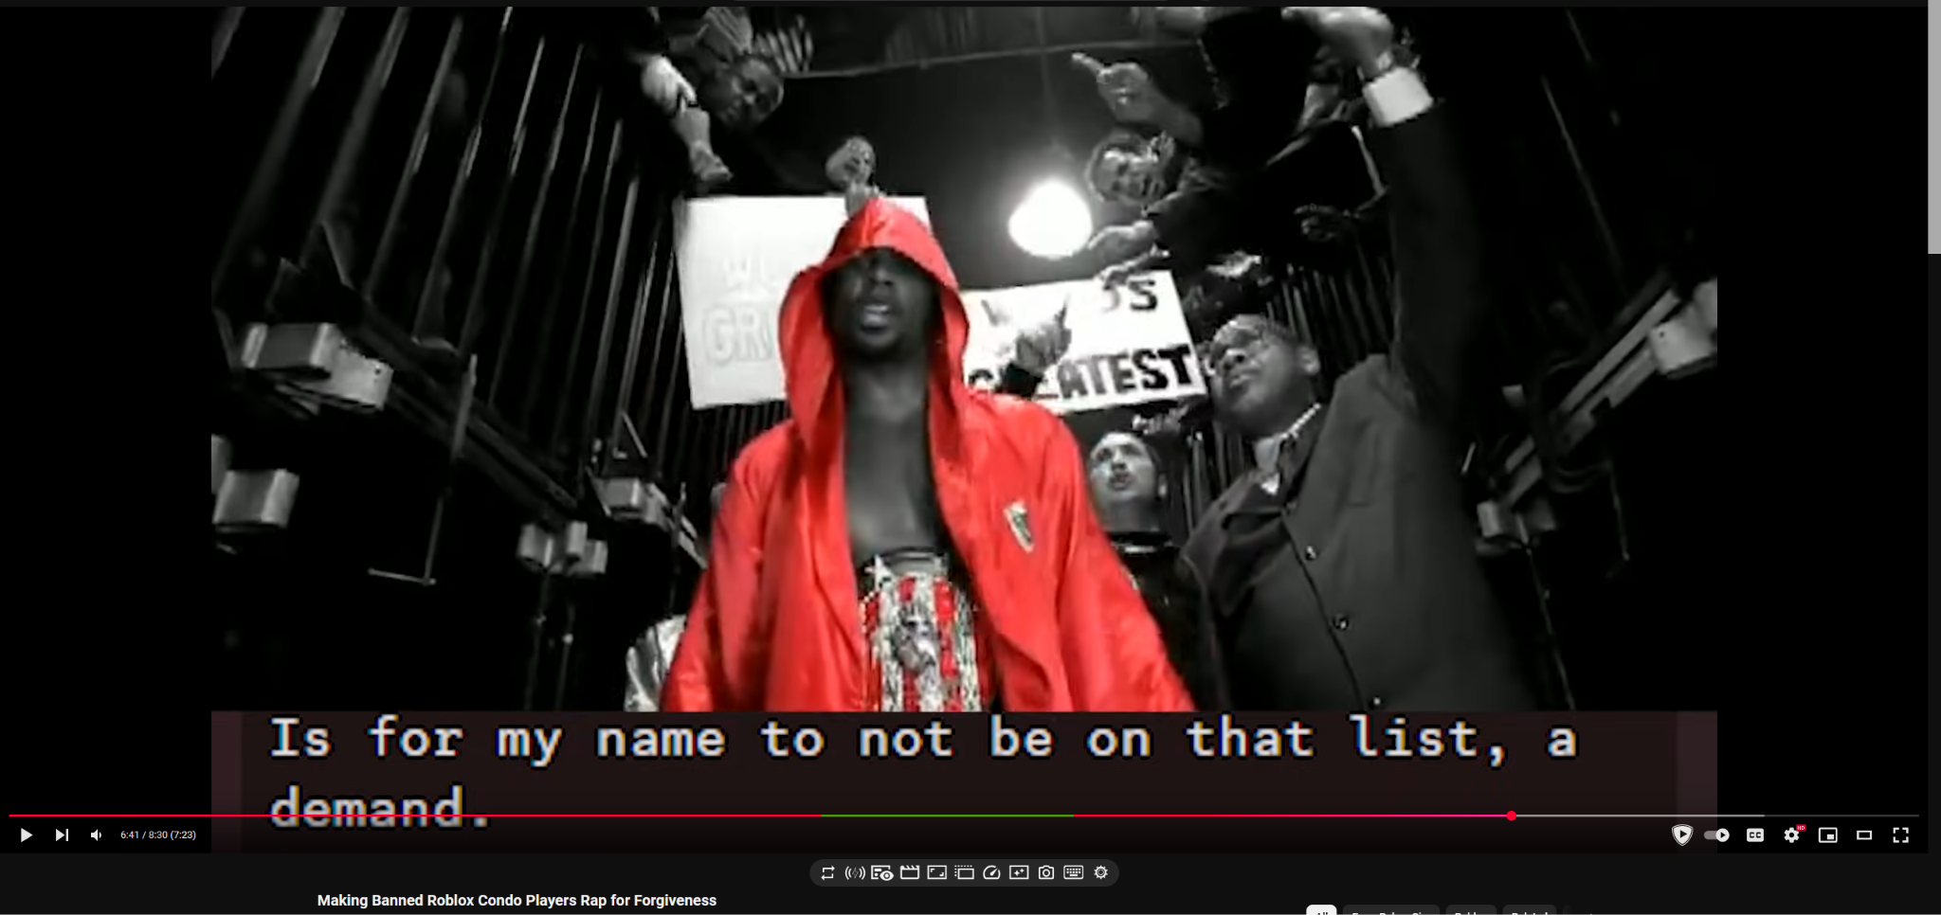

But yeah thats all I wanted to say keep gooning if you want I really dont know what you do just stay safe!

